**8. Hashing with Chaining**

Link: https://www.youtube.com/watch?v=0M_kIqhwbFo

**Dictionary**: Abstract Data Type (ADT) maintain set of items each with a key

* Insert (item)
* Delete (item)
* search(key): return item with given key or report doesn’t exist (key error in Python)

O(lg n) via AVL

Best search (logn) and best sort is (nlogn)

Use of dictionaries:

* Dictionaries are used in document distance problems where you need to find word count or word differences between two documents.
* Hash databases
* Spell Checkers
* Compilers and interpreters (old ones use dictionary to store variables and their values)
* Network router
* Substring search
* String commonalities
* Files and directories sync
* Cryptograhy

Simple approach:

* Direct access table
  + Store items in array indexed by key

Downsides of Hash Tables and Solutions:

* Keys may not be nonneg. Integers
  + Solution
  + Pre-hashing (Python calls it hash)
    - Maps keys to nonneg. Integer
    - In theory, keys are finite and discrete
      * Immutable objects such as integers, not lists
      * (string of bits)
    - In Python, hash(x) is the prehash of x
    - Ideally, hash(x) = hash(y) ⇔ x=y
* Gigantic memory hog
  + Solution
  + Reduce universe of all keys (integer) down to reasonable size m for table
  + Idea: m = O(n) (n being the amount of keys in dictionary)
  + Place all keys into a key space and map their location to a hash table
  + However, doing so may lead to collisions as multiple keys attempt to take up the same slot in the hash table
    - Solution
    - Chaining: linked list of colliding elements in each slot of hash table
      * Item will be a pointer to a linked list
      * Worst case: O(n)
      * Simple uniform hashing (unrealistic and based on false assumption) - each key is equally likely to be hashed to any slot of the table, independent of where other keys hashing
      * Analysis of SUH: expected length of chain for n keys, m slots
        + n/m = α = load factor
        + Θ(1) if m =Θ(n)
        + Running time = O(1+|chain|) = O(1+α)
* __hash__ allows you to make a custom function
* By default, Python uses id which is the physical location of your object in memory

Hash functions

* Division Method: h(k) = k mod m
  + No good if k and m has common factors
  + If both are even, it will only use half the table skipping odd positions
  + M should always be prime that is not near a power of 2 or power of 10
* Multiplication Method: h(k) = (a * k) mod 2**w >> (w-r)
  + Variable a should be random, odd, and not close to a power of 2
  + 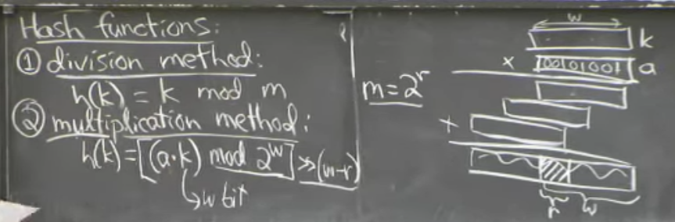
* Universal hashing: h(k) = [(ak + b) mod p] mod m
  + a = Random
  + b = t {0...p-1}
  + p = Prime > |U| (bigger than your universe)
  + For worst case keys k1 != k2:
    - Probability {h(k1) = h(k2)} = 1/m